Lakewood Primary School
Traffic Information and Map
2017-2018
Lakewood Primary School
- All Lakewood Primary traffic must access Explorer Drive from Silver Lake Drive
- Turn RIGHT into the school's entrance, drop off your Lakewood Birdie, and exit by turning LEFT on Explorer Drive.
- All traffic coming from Silver Lake Drive onto Explorer Drive will turn right into Lakewood Primary School starting August 7, 2017. No vehicles will be allowed to proceed straight towards Lakewood Elementary at this time. This will create a right turn only into Lakewood Primary School.

Only parents who have both an LPS student and an LES student may exit LPS by turning right on Explorer Drive.

Lakewood Elementary School
- All Lakewood Elementary traffic should access Explorer Drive by Pierce Road.
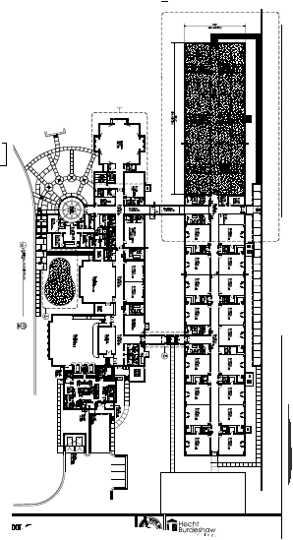
- After dropping off your Lakewood Explorer, exit by traveling straight through the 4-way stop on Explorer Drive to Pierce Road.
- All traffic coming from Pierce Road onto Explorer Drive will turn left into Lakewood Elementary. No one will be allowed to turn right towards Lakewood Primary starting August 7, 2017

Back of Building:
Car Rider Drop Off and Pick Up

EXPLORER DRIVE

Silver Lake Drive
Front Entrance:
Bus ONLY Drop Off and Pick Up

